**Hypothesis Testing**

Prepared by:

Name: **Nithin Thomas**

**CONTENTS**

**1. Goal of Analysis** 1

**2. Hypothesis Testing** 2

2.1. State your null and alternative hypothesis 2

2.2 State the significant level 2

2.3 Hypothesis Testing 2

2.3.1 Finding mu0, which is the POPULATION MEAN 2

2.3.2 Finding mu, which is the Sample MEAN 2

2.3.3 Specify the significance level 2

2.3.4 Sample standard deviation 3

2.3.5 Get the sample size 3

2.3.6 Calculate z 3

2.3.7 Calculate p-value 3

2.4. Either support or reject the null hypothesis. 4

2.5 Conclusion 4

**3. R Script used for the analysis** 5

**4. Reference** 7

# **1. Goal of Analysis**

The research team is trying to determine if an individual’s blood pressure has changed after exercising regularly for the past month (30-days).

Questions:

1. State the Hypothesis Statement that helps solve the research question

2. Provide a written step-by-step outline on how you would prove (or dis-prove) your hypothesis statements that you developed above.

3. Conduct the analysis you outlined in #2 in R

4. Summary of findings and conclusion

# **2. Hypothesis Testing**

Steps involve in hypothesis testing: -

## 2.1. State your null and alternative hypothesis

**Null Hypotheses, H0:** There is no significance difference in the mean blood pressure of individual’s before and after exercising regularly for the past month(30-days)..

**Alternative Hypotheses, H1:** There is significance difference in the mean blood pressure of individual’s before and after exercising regularly for the past month(30-days)..

## 2.2 State the significant level

**The significance level = 0.05**

## 2.3 Hypothesis Testing

**Two-Tail Test is caried out for the hypothesis testing.**

### 2.3.1 Finding mu0, which is the POPULATION MEAN

mu0 <- mean(BloodPressure$Before)

Output

138.28

### 2.3.2 Finding mu, which is the Sample MEAN

mu<- mean(BloodPressure$After)

Output

130.28

### 2.3.3 Specify the significance level

alpha <- 0.05

### 2.3.4 Sample standard deviation

sigma <- sd(BloodPressure$After)

sigma

Output

7.960946

### 2.3.5 Get the sample size

n <- nrow(BloodPressure)

n

Output

25

### 2.3.6 Calculate z

z<-(mu-mu0)/(sigma/sqrt(n))

z

Output

-5.024528

### 2.3.7 Calculate p-value

p =2*pnorm(abs(z),lower.tail=FALSE)

p

Output

5.046714e-07

## 2.4. Either support or reject the null hypothesis.

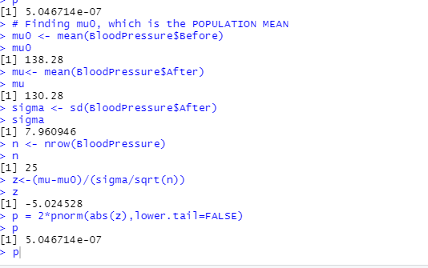

*Figure 2.4.1 RStudio Calculated P-Value*

Since **P-Value** of **5.046714e-07** is much lower than 0.05 confidence interval, therefore we **reject the Null hypothesis(H0)**, which states that there is no significant difference in the mean blood pressure of individual’s before and after exercising regularly for the past month(30-days).

## 2.5 Conclusion

We **reject** the **Null hypothesis(H0),** and **accept** **Alternative hypothesis(H1)**.

So, there is **significant difference in the mean blood pressure** of individual’s before and after exercising regularly for the past month(30-days) at the 0.05 level.

# **3. R Script used for the analysis**

#View Dataset

View(BloodPressure)

#View first few lines of dataset

head(BloodPressure)

#View key information of dataset

str(BloodPressure)

# Finding mu0, which is the POPULATION MEAN

mu0 <- mean(BloodPressure$Before)

mu0

# Finding mu, which is the Sample MEAN

mu<- mean(BloodPressure$After)

mu

# Specify the significance level

alpha <- 0.05

# sigma, Sample standard deviation

sigma <- sd(BloodPressure$After)

sigma

# n, Sample size

n <- nrow(BloodPressure)

n

#Calculate z

z<-(mu-mu0)/(sigma/sqrt(n))

z

#Calculate p-value

p = 2*pnorm(abs(z),lower.tail=FALSE)

p

# **4. Reference**

• Week 5>>Week5-Data1204 Slides from DC connect -> Course content